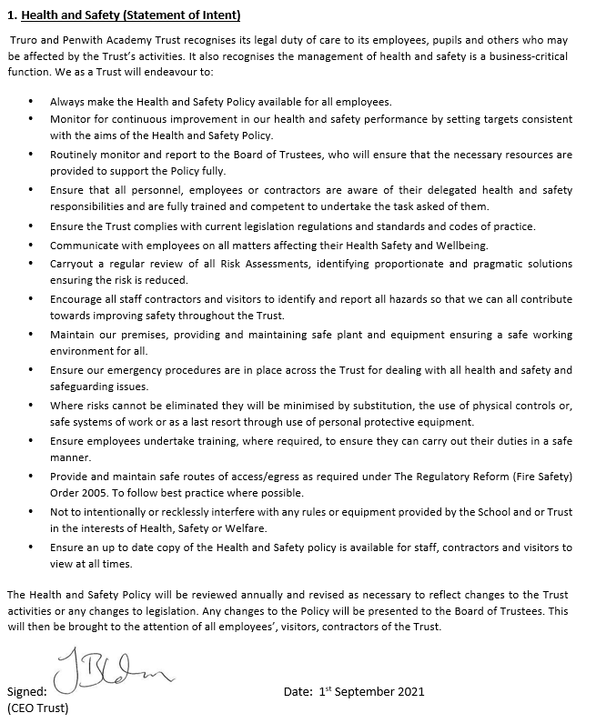

Date: ……17th May 2022…….

(Headteacher)