16th September 2016
Newsletter

We aim to create an exceptional school that harbours confidence, respect and a love of learning and prepares children for the challenges and adventures of life.

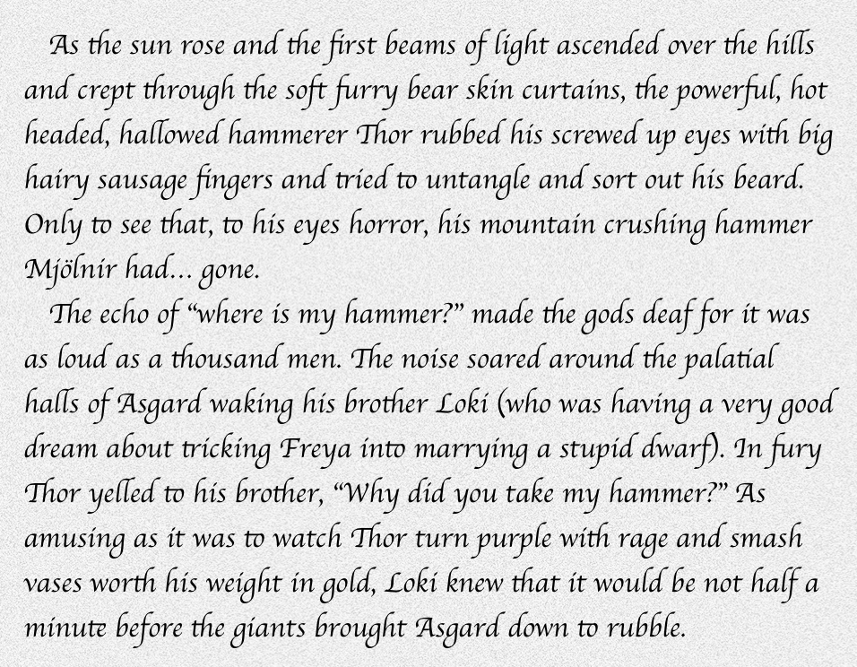
Some fantastic writing from Jonah in Year 6
Foxes Lane, Mousehole, Penzance,
Cornwall, TR19 6QQ
Tel: 01736
731 427
www.mousehole.cornwall.sch.uk
Welcome back everyone to the start of a new academic year. We would like to welcome the new pupils who have joined the school this term and thank everyone for ensuring the children are well prepared and looking smart at the beginning of another new academic year.
We are really pleased to once again have a nearly full school. Regardless of our status, the school is funded by pupil numbers. Maintaining the good reputation our school and keeping it full of pupils means we can maintain our class structure and staffing ratios and give ourselves the best chance of providing the best education and opportunities for the children.
The process of converting to an academy and joining the Penlee Academy Trust is still underway. A team of governors are working through our due diligence processes and ensuring that everything is as it should be before proceeding. This may take longer than originally thought (we are not going to rush the process) so our final conversion date may be delayed. In the meantime, we have created a document detailing the process so far which is available on the information page of our website.
Collaboration with the schools in PAT has already begun with a shared training session last week and a visit from Angela Armatage of EOS Education who will be working with us to further improve our Curriculum, Teaching and Learning, particularly around immersive project based learning.
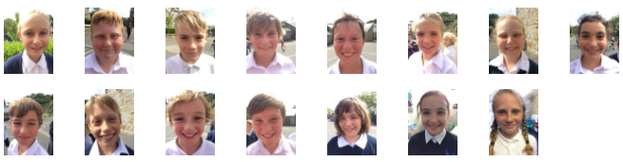
Congratulations to our Year 6 pupils for some fantastic Hustings. All the children did a brilliant job of presenting to the whole school and explaining why they were the best person for their chosen roles. Where there was more than one candidate for a particular role we used the votes from all the classes to make the final decision.
Last week Skiff Class launched their topic about what makes a super hero in super style! The whole class came to school dressed as a range of heroes from doctors to lifeguards to Team GB athletes and comic heroes. Just as we were having our class photo taken Iron Man himself whizzed through the playground on a super mission. He managed to find time for us to interview him, thank you Iron Man, you were amazing! Later in the day the Super Skiff's took part in some serious super hero training. Testing their super breath, jumping over buildings and leaping through flames were just some of the fabulous activities. We took photos of ourselves zooming through a city sky and created our own special super hero names. What a super day! Thank you parents and carers for your great help with costumes.
We endeavor to promote healthy lifestyles at Mousehole School this includes a healthy diet. If you provide your child with a snack for morning break please ensure it is healthy e.g. fruit, vegetables, seeds or nuts. We ask that the children do not eat crisps, chocolate or bars with high sugar content at break-time (we still relax the rules for crisp on a Friday). Bex in the school kitchen would like to remind you that healthy snack are available at the morning break time for only 30p. Our School Meals have remained the same price of £2.20 per meal but they must be paid for before the end of each week otherwise the school is charged by Chartwells for non-collection not to mention the time taken chasing payments. Your promptness is appreciated.
At our first Celebration Assembly Star Award’s of the new term the certificates went to Mercy, Ben and Flo in Skiff Class, Sawyer, Dylan and Poppy-Loveday in Lugger Class and Luke, Billy and Isla M in Schooner Class. Congratulations and well done, you are all Mousehole stars!
At the beginning of a new school year, it is important to remind everyone about considerate and appropriate Parking and Driving outside the school gates at the busy drop off and collection times. Unfortunately, one of our neighbours has already had access to their driveway blocked and they have asked for help from traffic police to monitor the parking around the school. You have been warned! Some parking is available on the estate at the back of the school or parking bays on Paul Lane. Parking at school is limited to staff only during the day but if you are collecting a child after a club at 4pm space should be available so please take advantage of this and do not block the school drive way.
Diary Dates for information:

Tuesday, 20th September – Swimming starts.
Wednesday, 21st September – Bikeability starts.
Wednesday, 21st September – World Peace Day choir event.
Tuesday, 4th October – Year 6 taster day at Humphry Davy School.
Thursday, 6th October – Schooner Class Porthmeor Studio visit.
Friday, 7th October – Skiff Class fire engine visit.
Wednesday, 12th October – Paul Feast concert at 6:00pm.
Friday, 14th October – FROMS Cake stall by Schooner Class.
Tuesday, 18th October – Olympic athlete visit.
Wednesday, 19th October – Skiff Class RNLI visit.
Monday, 24th October – Half term week.
Monday, 31st October – School will be CLOSED for staff training.
Monday, 19th December – Christmas holidays.

Don’t forget, dates can be found on the events page of our website.
www.mousehole.cornwall.sch.uk
Have a great weekend.

